"Kyiv Vocational College of Communication"

Cyclic Commission of Computer Engineering

EXECUTION REPORT

**Work - Case #8**

**from the discipline: "Operating systems"**

**Topic:** WORK-CASES IN LINUX

a list of additional practical tasks

from the discipline "Operating Systems"

It was performed by students of the RPZ group - 03B

Team 6: Sichkar Maxim,

Brytyuk Bohdan

Kyiv 2023

**Work-case 8**

1. When working with server systems or on computers, that's enough

are limited in resources, quite often the graphic shell is turned off or not at all

not set Sometimes there are problems that seem to be without graphics

shells cannot be executed, but this is not the case for the Linux OS. Try it

through the terminal, perform the following actions and explain which commands are used

(packages) they can be executed:

● View files and folders through the file manager in the terminal.

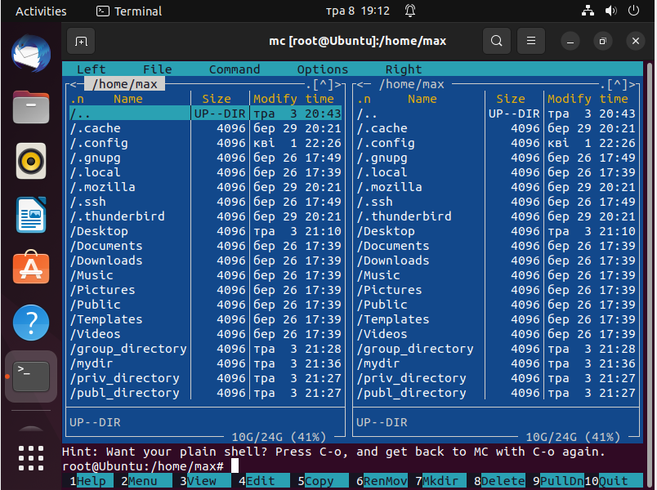

● View web pages through a browser running in the terminal.

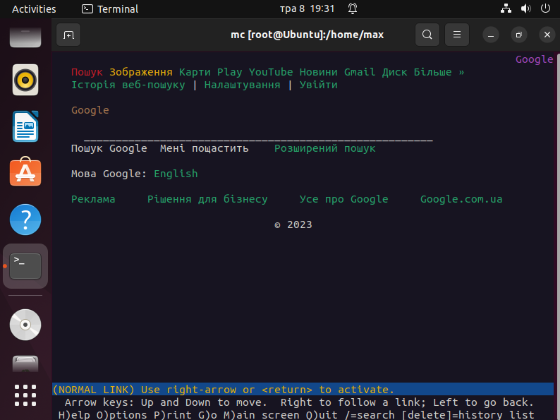

● View e-mail in the terminal.

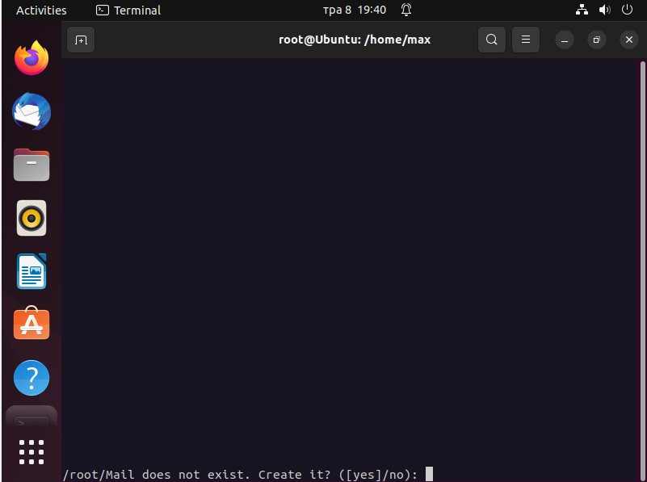

● Listen to music through the terminal.

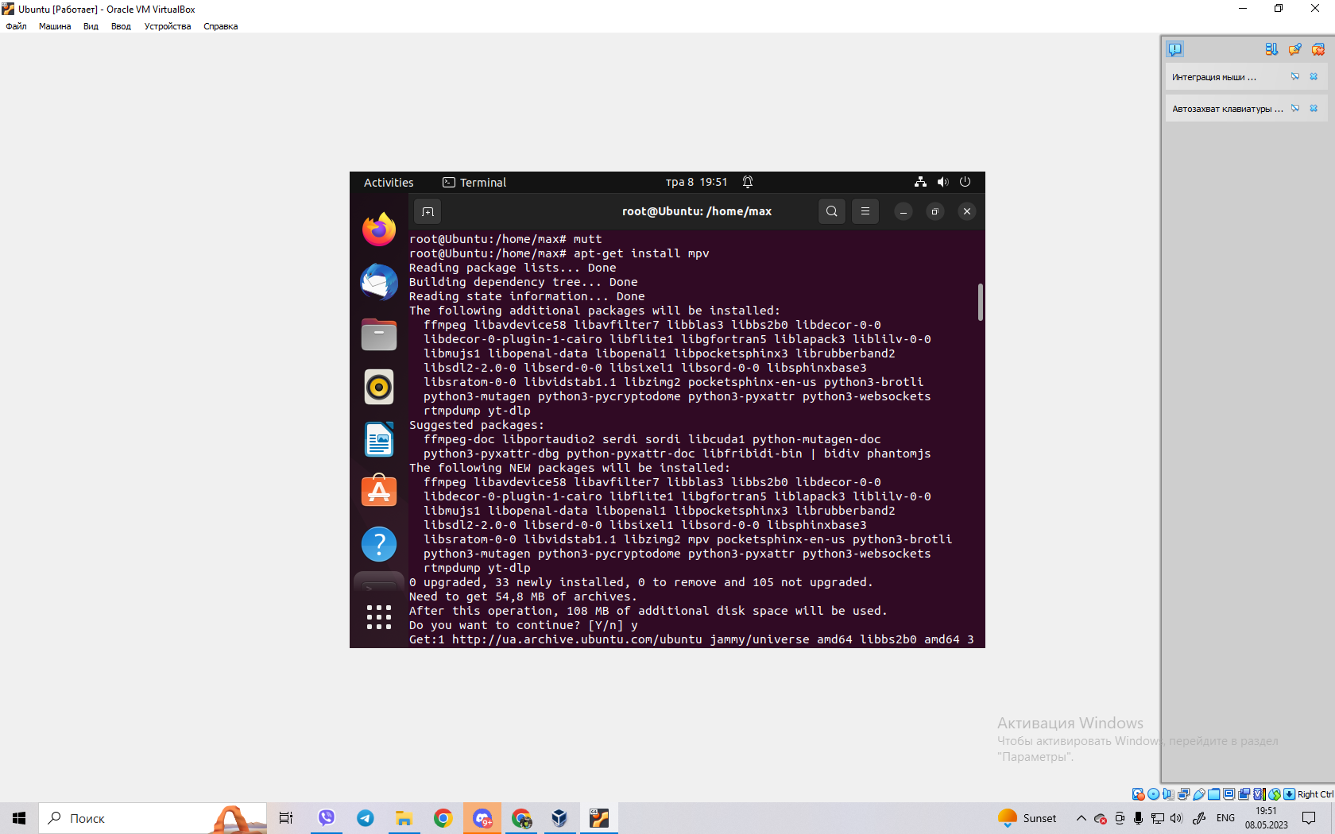

● Download torrents through the terminal.

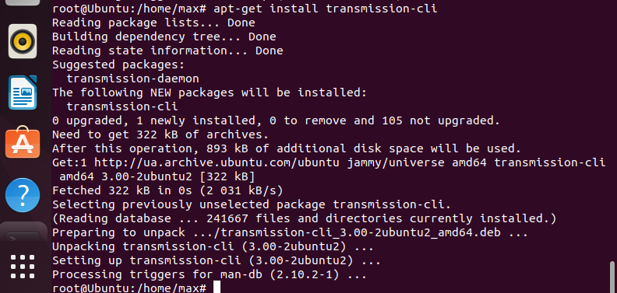

● Plan activities in the calendar and remind about them through the terminal.

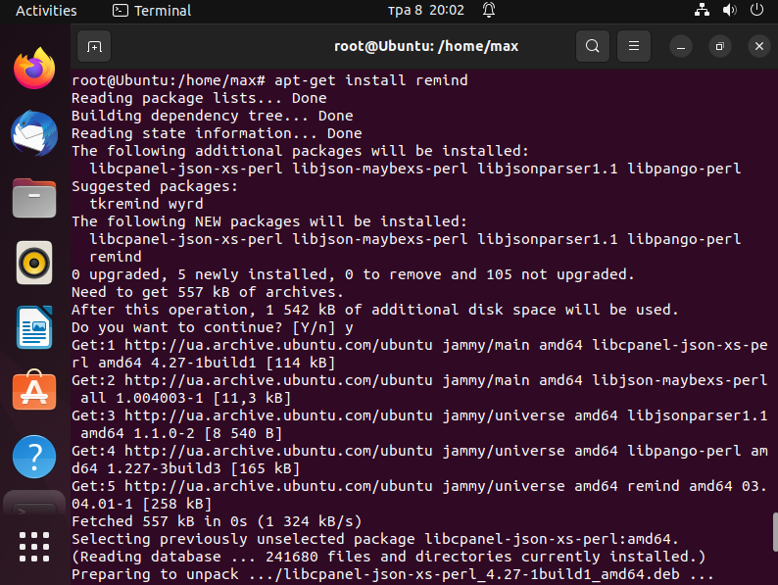

● View images in the terminal

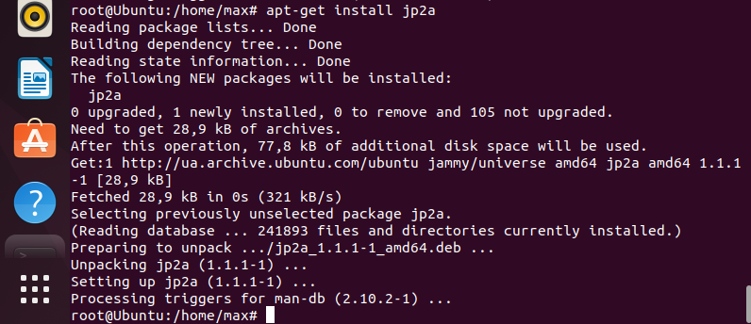

1. There are also actions that are classic for most administrators and have

quite diverse functionality. Describe different programs (commands,

packages) and install one for each action in the terminal:

● Enter, edit, delete text (file editors).

There are several text editors available in the terminal that can be used to enter, edit, and delete text files. Here are three popular ones:

Nano: Nano is a simple, user-friendly text editor that is easy to use for beginners. To install Nano, open the terminal and type the following command:

sudo apt-get install nano

Vim: Vim is a powerful, customizable text editor that is popular among experienced users. To install Vim, open the terminal and type the following command:

sudo apt-get install vim

Emacs: Emacs is a highly extensible text editor that can be customized to suit your needs. To install Emacs, open the terminal and type the following command:

sudo apt-get install emacs

Once you have installed the text editor of your choice, you can open and edit files in the terminal by typing the name of the editor followed by the name of the file you want to edit. For example, to edit a file called "mytextfile.txt" with Nano, you would type:

nano mytextfile.txt

This will open the file in Nano, where you can enter, edit, and delete text as needed.

● Monitor processes and system resources (similar to dispatcher

tasks or system monitor in the graphic shell).

To monitor processes and system resources in the terminal, you can use the following programs:

top: This is a command-line tool that displays real-time information about system processes, CPU usage, and memory usage. It is a great way to get a quick overview of what is happening on your system. To install top, you can use the following command:

sudo apt-get install top

htop: This is a more advanced version of top that provides more detailed information and a more user-friendly interface. It also allows you to interactively manage processes by selecting and sending signals to them. To install htop, you can use the following command:

sudo apt-get install htop

glances: This is another system monitoring tool that provides real-time information about CPU, memory, disk I/O, network, and other system resources. It has a web-based interface that can be accessed from any device on your network. To install glances, you can use the following command:

sudo apt-get install glances

All three of these programs are great options for monitoring system resources and processes in the terminal. Choose the one that best suits your needs and preferences.